CREATE TABLE EMPLOYEE(SSN NUMBER(3),FNAME VARCHAR(20),LNAME VARCHAR(20),SALARY NUMBER(38));
1. Write a Shell program to check the given number is even or odd.

#!/bin/bash
#Author: PONNU AUGUSTINE
#RollNo: 23MCA044
echo -n "Enter a number:";
read n;
echo -n "RESULT: ";
if [ `expr $n % 2` == 0 ]
then
echo "$n is even";
else
echo "$n is Odd";
fi

Output

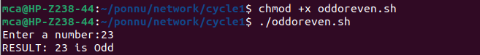

2. Write a Shell program to check a leap year.

#!/bin/bash
#Author: PONNU AUGUSTINE
#RollNo: 23MCA044
echo "Enter the year"
read y
b=`expr $y % 4`
if [ $b -eq 0 ]
then
echo "$y is a leap year"
else
echo "$y is not a leap year"
fi

Output

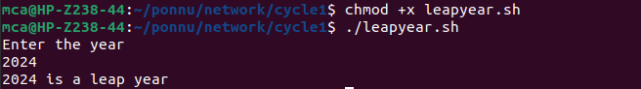

3. Write a Shell program to find the area and circumference of a circle.

#!/bin/bash
#Author: PONNU AUGUSTINE
#RollNo: 23MCA044
echo "Enter the radious of the circle"
read r
area=$(echo "3.14*$r*$r" | bc )
circum=$(echo "3.14*2*$r" | bc)
echo "area of the circle is " $area
echo "circumference of the circle is " $circum

Output

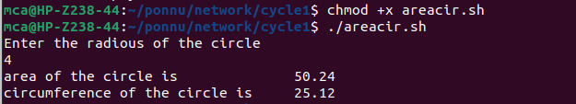

4. Write a Shell program to check the given number and its reverse are same.

#!/bin/bash
#Author: PONNU AUGUSTINE
#RollNo: 23MCA044
echo "enter number"
read n
num=0
original=$n
while [ $n -gt 0 ]
do
num=$(expr $num \* 10)
k=$(expr $n % 10)
num=$(expr $num + $k)
n=$(expr $n / 10)
done
echo "reverse is" $num
if [ $original -eq $num ]
then
echo "Number and reverse same"
else
echo "Number and reverse not same"
fi

Output

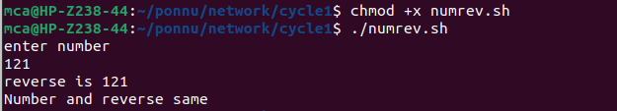
5. Write a Shell program to check the given string is palindrome or not.

#!/bin/bash
#Author: PONNU AUGUSTINE
#RollNo: 23MCA044
echo "Enter a String"
read input
reverse=""

len=${#input}
for (( i=$len-1; i>=0; i-- ))
do
reverse="$reverse${input:$i:1}"
done
if [ $input == $reverse ]
then
echo "$input is palindrome"
else
echo "$input is not palindrome"
fi

Output

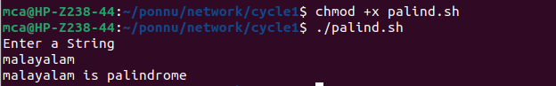

6. Write a Shell program to find the sum of odd and even numbers from a set of numbers.

#!/bin/bash
#Author: PONNU AUGUSTINE
#RollNo: 23MCA044
echo "Enter the length:"
read length
sumodd=0
sumeven=0
echo "Enter $length elements:"
for((i=0;i<length;i++))
{
read a[$i]
}

echo "The elements are: "
for((i=0;i<length;i++))
do {
echo ${a[$i]}
if(($((${a[$i]}%2))!= 0))
then sumodd=$(($sumodd+${a[$i]}))
else
sumeven=$(($sumeven+${a[$i]}))
fi
}
done
echo "Sum of odd elements: $sumodd"
echo "Sum of even elements: $sumeven"

Output

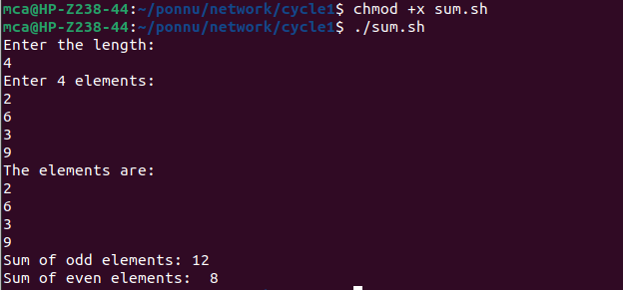

7. Write a Shell program to find the roots of a quadratic equation.

#!/bin/bash
#Author: PONNU AUGUSTINE
#RollNo: 23MCA044
read -p "a=" a
read -p "b=" b
read -p "c=" c

#finding value of x using quadratic formula
x1=$(echo "scale=2; ((-1*$b) + (sqrt(($b*$b)-(4*$a*$c))))/(2*$a)" | bc 2> /dev/null)
x2=$(echo "scale=2; ((-1*$b) - (sqrt(($b*$b)-(4*$a*$c))))/(2*$a)" | bc 2> /dev/null)

#in case the value of x cannot be found
if [[ $x1 == $null && $x2 == $null ]];then
echo value of x cannot be found
else
echo the roots are $x1 and $x2
fi

Output

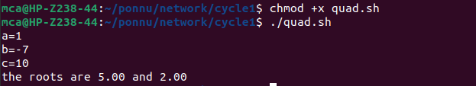

8. Write a Shell program to check the given integer is Armstrong number or not.

#!/bin/bash
#Author: PONNU AUGUSTINE
#RollNo: 23MCA044
echo "Enter an integer:"
read number
n=$number
sum=0

num_digits=${#number}

while [ $number -gt 0 ]; do
digit=$((number % 10))
sum=$((sum + digit ** num_digits))
number=$((number / 10))
done

if [ $sum -eq $n ]; then
echo "$n is an Armstrong number."
else
echo "$n is not an Armstrong number."
fi

Output

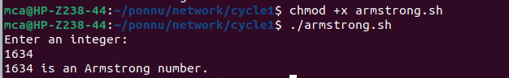

9. Write a Shell program to check the given integer is prime or not.

#!/bin/bash
#Author: PONNU AUGUSTINE
#RollNo: 23MCA044
echo “Enter a number:”
read n
flag=0
for((i = 2 ; i <= n / 2 ; i++))
do
r=`expr $n % $i`
if [ $r = 0 ]
then
flag=1
break
fi
done
if [ $flag = 0 ]
then
echo “$n is a prime number”
else
echo “$n is not a prime number”
fi

Output

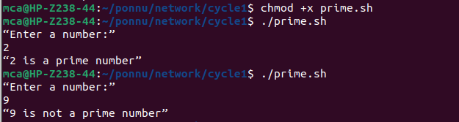

10. Write a Shell program to generate prime numbers between 1 and 50.

#!/bin/bash
#Author: PONNU AUGUSTINE
#RollNo: 23MCA044
for((n = 2 ; n <= 50 ; n++))
do
flag=0
for((i = 2 ; i <= n / 2; i++))
do
r=`expr $n % $i`
if [ $r = 0 ]
then
flag=1
break
fi
done
if [ $flag = 0 ]
then
echo $n
fi
done

Output

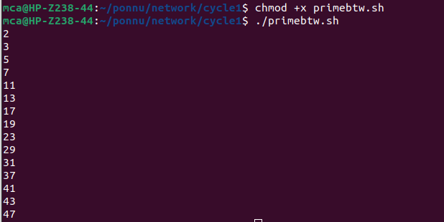

11. Write a Shell program to find the sum of square of individual digits of a number.

#!/bin/bash
#Author: PONNU AUGUSTINE
#RollNo: 23MCA044
echo Enter a number:
read n
t=$n
s=0
while [ $n -gt 0 ]
do
r=`expr $n % 10`
s=`expr $s + $r \* $r`
n=`expr $n / 10`
done
echo The sum of square of individual digits of $t is $s

Output

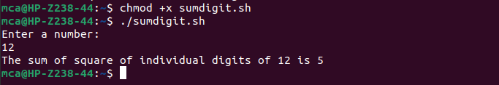

12. Write a Shell program to count the number of vowels in a line of text.

#!/bin/bash
#Author: PONNU AUGUSTINE
#RollNo: 23MCA044
echo -n "Enter a line of text: "
read string
vowCount=$(echo $string | grep -o -i "[aeiou]" | wc --lines)
echo "The given string has $vowCount vowels in it."

Output
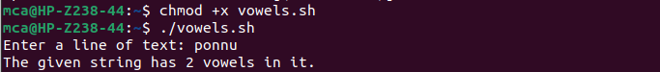

13. Write a Shell program to display student grades.

#!/bin/bash
#Author: PONNU AUGUSTINE
#RollNo: 23MCA044
echo Student Marksheet
echo Mark1:
read m1
echo Mark2:
read m2
echo Mark3:
read m3
total=`expr $m1 + $m2 + $m3`
echo Total Marks: $total out of 300
percentage=`expr $total / 3`
echo Percentage: $percentage %
if [ $percentage -ge 60 ]
then
echo A grade
elif [ $percentage -ge 50 ]
then
echo B grade
elif [ $percentage -ge 40 ]
then
echo C grade
else
echo Fail
fi

Output

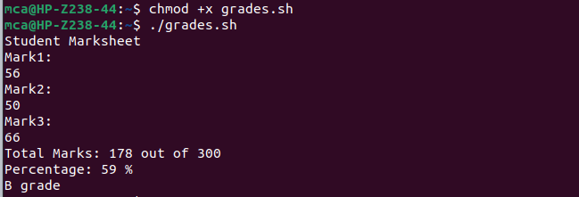

14. Write a Shell program to find the smallest and largest numbers from a set of numbers.

#!/bin/bash
#Author: PONNU AUGUSTINE
#RollNo: 23MCA044
read -p "Enter the numbers separated by spaces:" numbers
read -a num_array <<< "$numbers"
sorted_array=($(printf "%s\n" "${num_array[@]}" | sort -n))
smallest=${sorted_array[0]}
largest=${sorted_array[-1]}
echo Smallest number: $smallest
echo Largest number: $largest

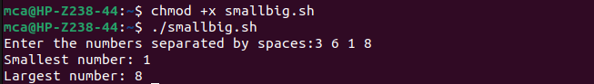

15. Write a Shell program to find the smallest digit from a number.

#!/bin/bash
#Author: PONNU AUGUSTINE
#RollNo: 23MCA044
echo Enter a number:
read n
s=9
while [ $n -gt 0 ]
do
r=`expr $n % 10`
if [ $r -lt $s ]
then
s=$r
fi
n=`expr $n / 10`
done
echo The smallest digit is : $s

Output

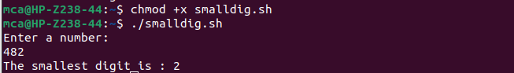

16. Write a Shell program to find the sum of all numbers between 50 and 100, which are
divisible by 3 and not divisible by 5.

#!/bin/bash
#Author: PONNU AUGUSTINE
#RollNo: 23MCA044
sum=0
divisible_numbers=""
for ((i=50; i<=100; i++)); do
if (( i % 3 == 0 )) && (( i % 5 != 0 ));
then
sum=$(( sum + i ))
# Append the current number to the list of divisible numbers
divisible_numbers="$divisible_numbers $i"
fi
done
echo Numbers between 50 and 100 divisible by 3 but not by 5:
echo $divisible_numbers
echo Sum of these numbers: $sum

Output

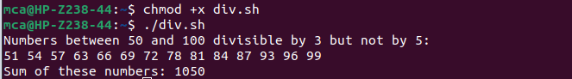
17. Write a Shell program to find the second highest number from a set of numbers.
#!/bin/bash
#Author: PONNU AUGUSTINE
#RollNo: 23MCA044
echo Enter the number of elements:
read n
a=0
b=0
echo Enter the number:
for((i = 1 ; i <= n ; i++))
do
read no
if [ $no -gt $a ]
then
b=$a
a=$no
elif [ $no -gt $b ]
then
b=$no
fi
done
echo The second highest number is : $b

Output

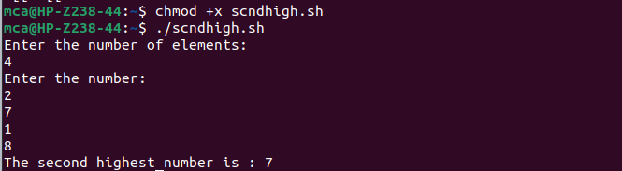

18. Write a Shell program to find the sum of digits of a number using function.

#!/bin/bash
#Author: PONNU AUGUSTINE
#RollNo: 23MCA044
sum_of_digits()
{
local num=$1
local sum=0
while [ $num -gt 0 ];
do
digit=$(( num % 10 ))
sum=$(( sum + digit ))
num=$(( num / 10 ))
done
echo $sum
}
read -p "Enter a number:" number
result=$(sum_of_digits $number)
echo Sum of digits of $number is $result

Output

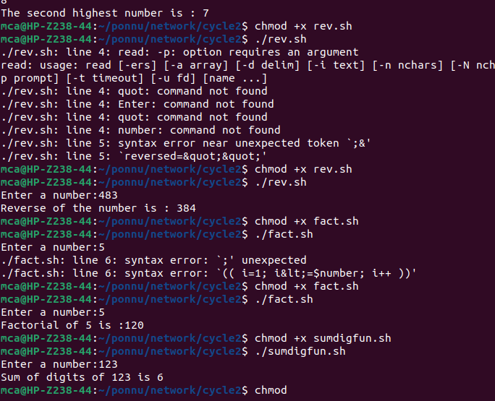

19. Write a Shell program to print the reverse of a number using function.

#!/bin/bash
#Author: PONNU AUGUSTINE
#RollNo: 23MCA044
read -p "Enter a number:" number
reversed=""
while [ $number -gt 0 ]; do
digit=$((number %10 ))
reversed="${reversed}${digit}"
number=$((number/10))
done
echo "Reverse of the number is : $reversed"

Output

20. Write a Shell program to find the factorial of a number using for loop.

#!/bin/bash
#Author: PONNU AUGUSTINE
#RollNo: 23MCA044
read -p "Enter a number:" number
factorial=1;
for (( i=1; i<=$number; i++ )); do
factorial=$((factorial*i))
done
echo "Factorial of $number is :$factorial"

Output

21. Write a Shell program to generate Fibonacci series.

#!/bin/bash
# Author name: Ponnu Augustine
#23mca044
echo "Enter the number of terms:"
read n
a=0
b=1
echo "Fibonacci Series:"
for ((i=0; i<n; i++)); do
echo "$a "
fn=$((a + b))
a=$b
b=$fn
done
Output
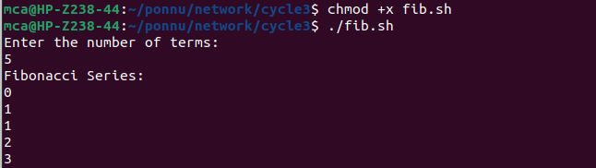

22. Write a shell script, which receives two filenames as arguments. It checks whether the two files contents are same or not. If they are same then second file is deleted.

#!/bin/bash
if [ $# -ne 2 ]; then
echo "Usage: $0 <file1> <file2>"
exit 1
fi
if [ ! -f "$1" ] || [ ! -f "$2" ]; then
echo "Error: Both files must exist"
exit 1
fi
if cmp -s "$1" "$2"; then
echo "The contents of '$1' and '$2' are identical."
echo "Deleting '$2'..."
rm "$2"
else
echo "The contents of '$1' and '$2' are different."
fi

Output

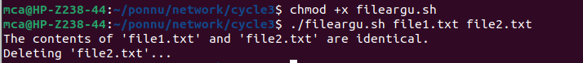

23. Write a Menu driven Shell script that Lists current directory, Prints Working Directory, displays Date and displays Users logged in.

#!/bin/bash
#Author: PONNU AUGUSTINE
#RollNo: 23MCA044
while true
do
clear
echo "Menu:"
echo "1. List current directory"
echo "2. Print working directory"
echo "3. Display date"
echo "4. Display users logged in"
echo "5. Exit"
read -p "Enter your choice: " choice
case $choice in
1)
ls -l
read -p "Press enter to continue"
;;
2)
pwd
read -p "Press enter to continue"
;;
3)
date
read -p "Press enter to continue"
;;
4)
who
read -p "Press enter to continue"
;;
5)
exit 0
;;
*)
echo "Invalid choice. Press enter to try again"
read
;;
esac
done

Output
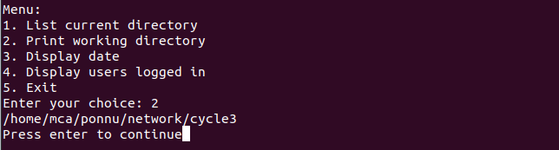

24. Shell script to check executable rights for all files in the current directory, if a file does not have the execute permission then make it executable.

#!/bin/bash
#Author: PONNU AUGUSTINE
#RollNo: 23MCA044
for file in *; do
if [[ ! -x "$file" ]]; then
chmod +x "$file"
echo "Made $file executable"
fi
done

25. Write a Shell program to generate all combinations of 1, 2, and 3 using loop.

#!/bin/bash
#Author: PONNU AUGUSTINE
#RollNo: 23MCA044
for i in 1 2 3
do
for j in 1 2 3
do
for k in 1 2 3
do
echo "$i $j $k"
done
done
done

Output

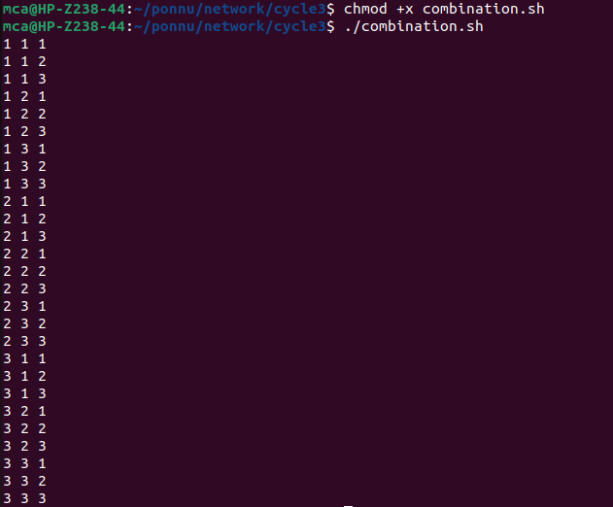

26. Write a Shell program to create the number series.

#!/bin/bash
#Author: PONNU AUGUSTINE
#RollNo: 23MCA044
num=1
row=1
while [ $row -le 4 ]; do
for (( i=1; i<=$row; i++ )); do
echo -n "$num "
num=$((num+1))
done
echo ""
row=$((row+1))
done

Output

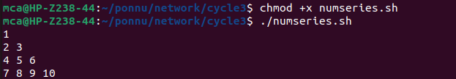

27. Write a Shell program to create Pascal’s triangle.

#!/bin/bash
#Author: PONNU AUGUSTINE
#RollNo: 23MCA044
function binom {
if [ $2 -eq 0 ] || [ $2 -eq $1 ]; then
echo 1
else
echo $(( $(binom $(($1-1)) $(($2-1))) + $(binom $(($1-1)) $2) ))
fi
}
echo "Enter the number of rows in Pascal's triangle: "
read rows
for (( i=0; i<$rows; i++ )); do
for (( j=0; j<=$i; j++ )); do
val=$(binom $i $j)
echo -n "$val "
done
# Move to next row
echo ""
done

Output
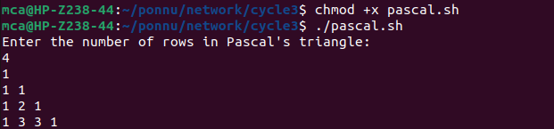

28. Write a Decimal to Binary Conversion Shell Script.

#!/bin/bash
#Author: PONNU AUGUSTINE
#RollNo: 23MCA044
echo "Enter a decimal number: "
read decimal
# Convert the decimal number to binary
binary=""
while [ $decimal -gt 0 ]; do
remainder=$((decimal % 2))
binary="$remainder$binary"
decimal=$((decimal / 2))
done
# Print the binary number
echo "The binary equivalent is: $binary"

Output

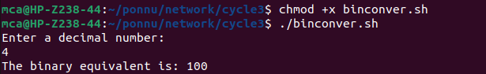

29. Write a Shell Script to Check Whether a String is Palindrome or not.

#!/bin/bash
#Author: PONNU AUGUSTINE
#RollNo: 23MCA044
echo "Enter a string: "
read string
# Reverse the string
reverse=$(echo $string | rev)
# Check if the string is equal to its reverse
if [ "$string" == "$reverse" ]; then
echo "$string is a palindrome."
else
echo "$string is not a palindrome."
fi

Output
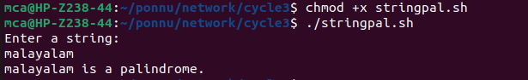

30. Write a shell script to find out the unique words in a file and also count the occurrence of each of these words.

#!/bin/bash
#Author: PONNU AUGUSTINE
#RollNo: 23MCA044
echo "Enter the file name: "
read file
# Check if the file exists
if [ ! -f "$file" ]; then
echo "File not found."
exit 1
fi
# Convert the contents of the file to lowercase and replace all non-alphanumeric characters with spaces
contents=$(tr '[:upper:]' '[:lower:]' < "$file" | sed 's/[^a-z0-9]/ /g')
# Create an array of words from the file contents
words=($contents)
# Loop through the array of words and count their occurrences
declare -A count
for word in "${words[@]}"; do
if [ -n "$word" ]; then
((count[$word]++))
fi
done
# Print the unique words and their counts
echo "Unique words in $file:"
for word in "${!count[@]}"; do
echo "$word: ${count[$word]}"
done

Output
